Project Planning Phase
Project Planning Template (Product Backlog, Sprint Planning, Stories, Story points)

Date | 01 November 2026
Team ID | NA
Project Name | Electric Vehicle Market Performance & Insights
Maximum Marks | 8 Marks

Product Backlog, Sprint Schedule, and Estimation (4 Marks)
Use the below template to create product backlog and sprint schedule
Sprint | Functional Requirement (Epic) | User Story Number | User Story / Task | Story Points | Priority | Team Members
Sprint-1 | Data Collection | USN-1 | Get the cleaned EV dataset (ev_market_clean.csv) | 2 | High | Princy Malviya
Sprint-1 | Data Preparation | USN-2 | Connect to Tableau, check types, create extract | 3 | High | Princy Malviya
Sprint-1 | Data Preparation | USN-3 | Create 6 KPI fields, Model Year Label and Autonomy Level | 3 | High | Princy Malviya
Sprint-1 | Planning | USN-4 | Map the 3 scenarios to business questions | 2 | High | Princy Malviya
Sprint-2 | Visualisation | USN-5 | EV Specs Overview (KPIs) | 2 | High | Princy Malviya
Sprint-2 | Visualisation | USN-6 | Annual Sales by Use Case | 2 | High | Princy Malviya
Sprint-2 | Visualisation | USN-7 | Average Price by Vehicle Category | 2 | High | Princy Malviya
Sprint-2 | Visualisation | USN-8 | Customer Rating by Battery Type | 2 | High | Princy Malviya
Sprint-2 | Visualisation | USN-9 | Annual Sales by Manufacturing Country | 2 | High | Princy Malviya
Sprint-3 | Visualisation | USN-10 | Drivetrain Mix by Category (stacked bar) | 2 | Medium | Princy Malviya
Sprint-3 | Visualisation | USN-11 | Autonomy Level Distribution (pie) | 2 | Medium | Princy Malviya
Sprint-3 | Visualisation | USN-12 | Average Range Trend by Model Year (line) | 2 | Medium | Princy Malviya
Sprint-3 | Visualisation | USN-13 | Top Speed vs Acceleration (scatter) | 2 | Medium | Princy Malviya
Sprint-3 | Dashboard & Story | USN-14 | EV Specs & Sales Dashboard with 3 filters + 3-point Story | 5 | High | Princy Malviya
Sprint-4 | Deployment | USN-15 | Publish to Tableau Public | 2 | High | Princy Malviya
Sprint-4 | Testing | USN-16 | Performance testing and value checks | 2 | High | Princy Malviya
Sprint-4 | Documentation | USN-17 | Templates and final report | 3 | High | Princy Malviya
Sprint-4 | Demonstration | USN-18 | Demo video | 2 | Medium | Princy Malviya
Sprint-4 | Deployment | USN-19 | GitHub repository | 2 | Medium | Princy Malviya

Project Tracker, Velocity & Burndown Chart: (4 Marks)
Sprint | Total Story Points | Duration | Sprint Start Date | Sprint End Date (Planned) | Story Points Completed (as on Planned End Date) | Sprint Release Date (Actual)
Sprint-1 | 10 | 1 Day | 31 Oct 2026 | 31 Oct 2026 | 10 | 31 Oct 2026
Sprint-2 | 10 | 1 Day | 01 Nov 2026 | 01 Nov 2026 | 10 | 01 Nov 2026
Sprint-3 | 13 | 1 Day | 02 Nov 2026 | 02 Nov 2026 | 13 | 02 Nov 2026
Sprint-4 | 11 | 1 Day | 03 Nov 2026 | 03 Nov 2026 | 11 | 03 Nov 2026

Velocity:
Imagine we have a 10-day sprint duration, and the velocity of the team is 20 (points per sprint). Let’s calculate the team’s average velocity (AV) per iteration unit (story points per day)
For this project: 44 story points over 4 one-day sprints. Velocity = 44 ÷ 4 = 11 points per sprint; Average Velocity = 11 ÷ 1 day = 11 points per day.


Burndown Chart:
A burn down chart is a graphical representation of work left to do versus time. It is often used in agile software development methodologies such as Scrum. However, burn down charts can be applied to any project containing measurable progress over time.
Burndown chart of this project:
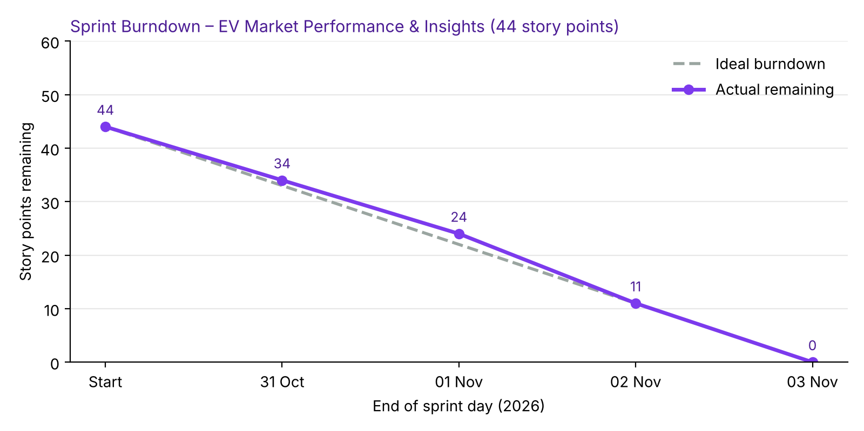

https://www.visual-paradigm.com/scrum/scrum-burndown-chart/
https://www.atlassian.com/agile/tutorials/burndown-charts

Reference:
https://www.atlassian.com/agile/project-management
https://www.atlassian.com/agile/tutorials/how-to-do-scrum-with-jira-software
https://www.atlassian.com/agile/tutorials/epics
https://www.atlassian.com/agile/tutorials/sprints
https://www.atlassian.com/agile/project-management/estimation
https://www.atlassian.com/agile/tutorials/burndown-charts

